NAME: _____________ | Statistics and Probability
8-3 Hypothesis testing quiz | DATE: Thursday, January 14, 2016

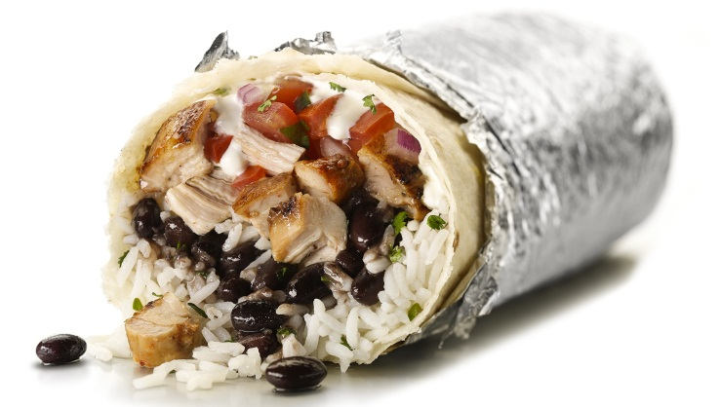
Chipotle claims that only 15% of their customers become sick after eating their food. You believe that Chipotle is lying, because everytime you go you get sick. You contact a random sample of 80 and find 15 people were sick. Do you have evidence (at 95% confidence) that Chipotle is lying?

.

Show all work and calculations. Write a conclusion in context.

NAME: _____________ | Statistics and Probability
8-3 Hypothesis testing quiz | DATE: Thursday, January 14, 2016

Chipotle claims that only 15% of their customers become sick after eating their food. You believe that Chipotle is lying, because everytime you go you get sick. You contact a random sample of 80 and find 15 people were sick. Do you have evidence (at 95% confidence) that Chipotle is lying?

.

Show all work and calculations. Write a conclusion in context.

